30/05/20

**THM 121 Business Mathematics**

**Final Exam Answer Sheet**

**Note to the students**:

* Calculations to reach your answers shall be thoroughly shown. Otherwise, questions will NOT be graded.
* You can use a calculator throughout the exam.

1. Consider the following equation of a line: 5y – 3χ = 4
2. Find the **slope** and the **intercepts** of the line. (**3** Points)

5y – 3χ = 4 ↔ 5y = 3χ + 4 ↔ y = (3/5)χ + (4/5)

Therefore, the slope of the line is **3/5**. In order to find the intercepts:

χ intercept: set y = 0 and solve for χ → χ intercept is **(-4/3, 0)**.

y intercept: set χ = 0 and solve for y → y intercept is **(0, 4/5)**.

1. Sketch the **graph** of the line. (**2** Points)
2. A car rental agency charges **$ 40** per day plus **65** cents per kilometer.
3. Express the cost of renting a car from this agency *for 1 day* as a function of the number of kilometers driven. (**1** Point)

Let χ denote the number of kilometers driven and *C(*χ) the corresponding cost (in dollars). Therefore, ***C*(χ) = 0.65χ + 40**.

1. Draw the **graph** of this function (**2** Points)
2. How **much** does it cost to rent a car for a 1-day trip of 163 kilometers? (**1** Point)

The rental cots of a 163-kilometer trip is: *C*(163) = (0.65 * 163) + 40 = **$ 145.95**.

1. The agency also offers a rental for a flat fee of **$ 125 per day**. How many kilometers must you drive on a 1-day trip for this to be a better deal? (**2** Points)

In order to answer this question, we have to solve the following equation:

0.65χ + 40 = 125 ↔ 0.65χ = 85 ↔ χ ≈ 130.77 kilometers.

Therefore, if someone drives, on a daily basis, **131 kilometers and more**, the flat fee would be a better deal.

3) A furniture manufacturer can sell dining room tables for **$ 500** each. The manufacturer’s total cost consists of a fixed overhead of **$ 30,000** plus production costs of **$ 350** per table.

a) How many **tables** must the manufacturer sell to break even? (**2** Points)

If χ is the number of tables produced then the manufacturer’s cost function is *C*(χ) = 350χ + 30000 while the revenue function is *R*(χ) = 500χ. The break-even point is where *R*(χ) = *C*(χ) ↔ 500χ = 350χ + 30000 ↔ 150χ = 30000 ↔ χ = 200.

Therefore, the manufacturer must sell **200 tables** to break even.

b) How many **tables** must the manufacturer sell to make a profit of $ 6,000? (**1** Point)

Since profit is the difference between revenue and cost, the profit function *P*(χ), is 500χ – (350χ + 30000) = 150χ – 30000. For the profit to be $ 6,000, χ must satisfy 150χ – 30000 = 6000 ↔ 150χ = 36000 ↔ χ = 240.

Therefore, selling **240 tables** yields a profit of $ 6,000.

1. What will be the manufacturer’s **profit** or **loss** if 150 tables are sold? (**1** Point)

*P*(150) = (150 * 150) – 30000 = - $ 7500.

Therefore, if 150 tables are sold, the company will incur **$ 7,500 loss**.

1. On the same set of axes, **graph** the manufacturer’s total revenue and total cost functions. Explain how the **overhead cost** can be read from the graph. (**3** Points)
2. It costs a publisher $ 74,200 to prepare a book for publication (typesetting, illustrating, editing…); printing and binding costs are $ 5.50 per book. The book is sold to bookstores for $ 19.50 per copy.
3. Make a table showing the **cost** of producing 2,000 , 4,000 , 6,000 , and 8,000 books. (**1** Point)

Let χ be the number of books and *C* be the cost of producing χ books. Therefore, *C*(χ) = 5.5χ + 74200



1. Make a table showing the **revenue** of producing 2,000 , 4,000 , 6,000 , and 8,000 books? (**1** Point)

Let χ be the number of books and *R* be the revenue from the sale of χ books. Therefore, *R*(χ) = 19.5χ



1. Write an **algebraic expression** representing the cost **y** as a function of the number of books **χ** that are produced. (**1** Point)

***C*(χ) = 5.5χ + 74200**

1. Write an **algebraic expression** representing the revenue **y** as a function of the number of books **χ** that are sold? (**1** Point)

*R***(χ) = 19.5χ**

1. **Graph** both functions on the same coordinate axes. (**3** Points)
2. Use the graph to determine how many **books** need to be made to produce revenue of at least **$ 85,000**. How much **profit** is earned for this number of books? (**2** Points)

Looking at the above graph, it appears that approximately **4,360 books** shall be sold to produce a revenue of al least $ 85,000. Moreover, at this very level of sales, a loss of **$ 13,160** occurs.

1. Jamel, the organizer of a sports event, estimates that if the event is announced χ days in advance, the revenue obtained will be *R*(χ) thousand dollars, where

***R (χ*) = 400 + 120χ – χ2**

The cost of advertising the event for χ days is *C*(χ) thousand dollars, where

***C* (χ) = 2χ2 + 300**

1. Find the profit function **P (χ)** = R (χ) – C (χ), and **sketch the graph**. (**3** Points)

**P (χ)** = R (χ) – C (χ) = 400 + 120χ – χ2 – (2χ2 + 300) = **-3χ2 + 120χ + 100**.

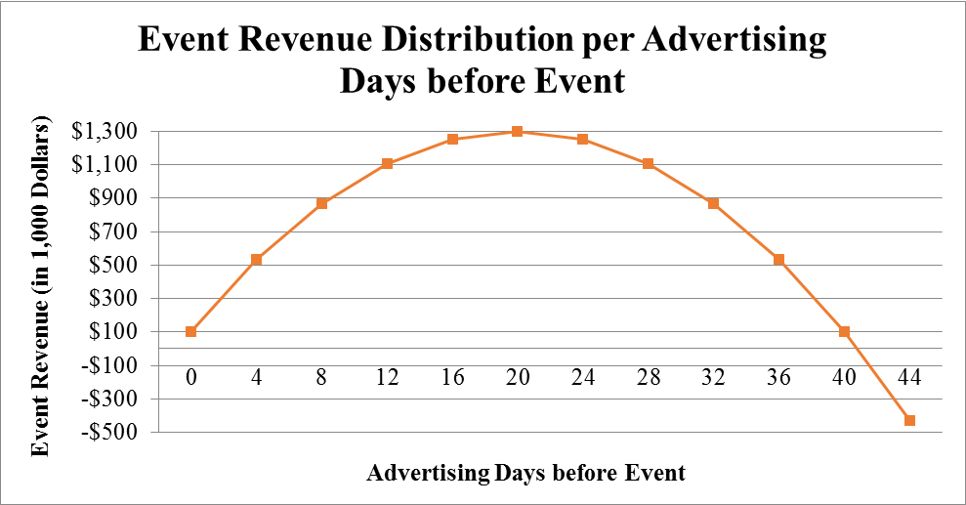

1. How many **days** in advance should Jamel announce the event to **maximize profit**? What is the **maximum profit**? (**2** Points)

The maximum profit occurs when χ = 20. Therefore, the event shall be announced **20** days in advance to maximize profit. Moreover, this very profit can be calculated as:

P(20) = -3 * (20)2 + 120 *20 + 100 = - 1200 + 2400 + 100 = 1300.

Thus, the maximum profit is **$ 1,300,000**.

1. What is the ratio of revenue to cost

***Q* (χ)** = *R* (χ) / *C* (χ)

at the optimal announcement time found in part (b)? What happens to this ratio as χ → 0? **Interpret** these results. (**2** Points)







Therefore, at the optimal announcement time, the revenue is more than the **double** of the advertising cost. Moreover, as the announcement date gets closer to the event, the revenue gets closer to **4/3** of the advertising cost.

1. In certain situations, it is necessary to weigh the benefit of pursuing a certain goal against the cost of achieving that very goal. For instance, suppose that to remove χ% of the population from an oil spill, it costs *C* thousands of dollars, where

***C* (χ) = 12χ / (100 – χ)**

1. How much does it **cost** to remove **25%** of the pollution? **50%**? (**2** Points)

C (25) = (12 * 25) / (100 – 25) = 4 → **$ 4,000**.

C (50) = (12 * 50) / (100 – 50) = 12 → **$ 12,000**.

1. Sketch the graph of the cost function. (**2** Points)

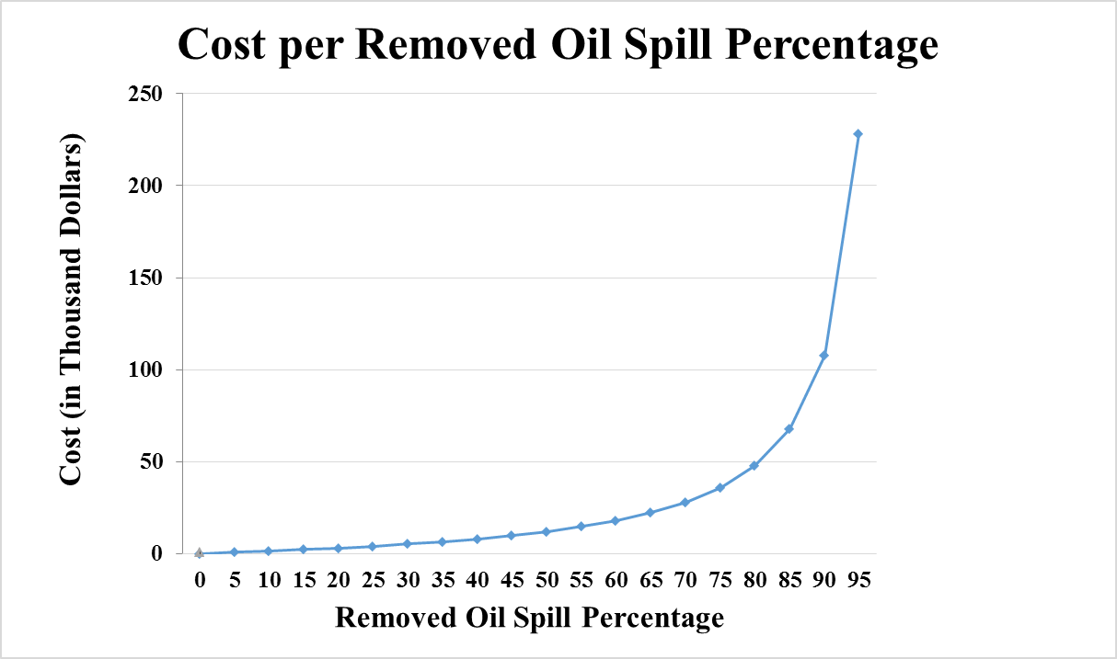

1. What happens as **χ → 100-**? Is it **possible** to remove **all** the pollution? (**2** Points)

From the above graph, Therefore, it is **impossible** to remove all of the population.

**N.B**. Round your answers to the **nearest cent** for questions 2, 3, 4, 5 & 6.

**GOOD LUCK!**